**Literature review of Sentiment analysis on Social Networking sites: Case Study on**

**Twitter using cognitive services**

**ABSTRACT**

***Purpose* –** This paper proposes a systematic literature review of sentiment analysis on social media to provide an overview of the studies in the domain. Further, this paper emphasizes on the use of Sentiment analysis for understanding the view point on global scale regarding Covid-19 via Social networking sites by collecting the data in logical way from Microsoft Azure and cognitive services.

***Design/methodology/approach* –** In this study, we have done a systematic literature review of sentiment analysis on social media by applying the bibliometric search, descriptive analysis, and scientometric analysis. Further, we chose “Twitter”, a social media platform for analysis of sentiments regarding Covid-19 pandemic for a case study. We uniquely proposed the model for data collection and ML algorithms to analyse the sentiment analysis related to covid-19 over the Twitter platform. In this proposed model, cognitive services were used to collect the details of comments made related to covid-19 over Twitter platform. Further, the classification of this collected data was done using machine learning (ML) techniques, such as, SVM (Support Vector Machine)and Random forest in this case study.

***Findings* –** We listed down all the research papers related to sentiment analysis about Covid-19. We compared and discussed the different data collection methods and ML algorithms procedures used in the major research contributions. In our case study, we collected the data from Twitter API, and the algorithms SVM and Random forest were generated and compared. This analysis concluded that SVM (F1 score 78%) performs better in comparison with Random forest (F1 score of 75%). As observed, Natural Language Processing (NLP) Score tends towards 1, which represents that people are mostly sending negative tweets and misleading information due to panic and non-availability of the accurate information.

***Research limitations/implications* –**Our study is limited to Covid-19 over Twitter platform but can be generalised and used on various events like elections, privatisations, etc. The proposed model is using only SVM and Random forest while the combinations of multiple algorithms such as Artificial Neural Network (ANN) etc for improved accuracy and robustness.

***Practical implications* –** This study brings out a methodology to analyse the sentimental data to predict the general thoughts of people around due to covid-19. The classification of training data set will be helpful to test and predict the scenario about the second wave of Covid-19. Our work helps to minimise the negativity of the human thoughts through their tweets over Twitter about Covid-19. The proposed algorithms help to control the negative comments which facilitate the authorities to stabilise the situation. These logical and technological control can be extended to other social media platforms, press, journals, news channels, etc.

***Originality/value* –** The findings can be utilised by concern authorities to control such situations with the simple method and technique proposed in this paper. The machine learning algorithms SVM and Random forest have been used uniquely to analyse the sentiment analysis for twitter about covid-19 for the first time.

***Keywords*** *-* Social Networking, Machine Learning, Cognitive Services, Twitter, Sentiment Analysis, Predictive analysis, Facebook, LinkedIn, Google+, Whatsapp, Instagram.

***Paper type* -** Research paper

**1. Introduction**

In today’s world, people have changed their lifestyle by use of the internet. Nowadays most people use various social media platforms to interact to different individuals, communities, social groups to exchange their thoughts through different verbal / written languages, pictures and emotions. These expression in the form of comments are creating a huge dataset to analyse and predict the overall impact of these comments to other readers/ viewers. Many times such comments may influence the masses for creating an overall positive or negative psychology. Hence, it becomes important for the administrators of social media platform to analyse and control such psychological impact to its users/viewers. The analysis of such comments help to control its impact by filtering out the influential comments from the readers accessibility. Sentiment analysis is one of the methods to evaluate the opinion of general public regarding some event, product or service (Kim et al. 2020) which may be positive, negative or neutral (Saxena et al., 2020) form the most common social media platforms like Twitter, Facebook, Quora, Instagram, LinkedIn, YouTube, WhatsApp, Tumblr, Reddit, etc (Alamoodi et al. 2020). Traditionally, people used to express their views by public gatherings, printed media, through supportive groups or institutions and live audio visual media critics (Bradford et al. 2020). Sentiment analysis helps us to analyse opinion of general mass and understand psychological view point of consumers regarding an event or product (Alamoodi et al. 2020). Sentiment analysis can be generally done by two methods Lexicon-based and ML techniques (Awajan et al. 2021). Pre-defined data sets of large volumes are primarily used and pre-processed for filtering out sentences, misspelling, punctuations, emoji’s, etc for detecting emotions in Lexicon-based technique (Basiri et al., 2020). ML approach and data collection techniques proposed in this paper can be used without pre-processing on run time data.

Different online and offline businesses also prefer to take the help of customer feedback to improve their services while offering any new product or service (Yi, S., & Liu, X. 2020). Organisations find it challenging to judge the emotions of public wether their future work plan is appropriate to the situation or not. There is also a possibility that the people providing feedback may not give honest review due to their personal circumstances or some biased mindset, getting the honest opinion of mass is a very difficult and time consuming process when done by the conventional feedback methods (Barkur, G., &Vibha, G. B. K. 2020). This will not the case when machine learning techniques are used for sentiment analysis since in the online social media plate form people are expressing their opinion freely without any constrain of being judged. Thus the possibility of biased opinion or feedback is ruled out in this technique (Zheng et al. 2015).

Covid-19 is a pandemic which started in Feb 2020 across the world it impacted all the humans mentally, physically, financially, etc.(...). It is very difficult to obtain the accurate and updated literature insights regarding covid-19 as this pandemic has not over yet. (Hamzah et al., 2020). Many of the economies attempted to revive after its first wave, recently the second wave is also started across the globe. Social media is widely used for gathering information and expressing the thoughts on covid-19. Twitter is one such social media platform used by people to express their views and perceptions in written form with a limitation of 140 characters. Facebook and Instagram allow the user to express in form of short videos and pictures where it’s challenging to predict sentiments from that small text and pictures (Ruz et al. 2020). Approximately 11 million Twitter users are active worldwide who post around 5billion tweets per day on average. A large amount of real-time data is generated regularly that can be utilised to predict sentiments of the mass efficiently with the help of machine learning algorithms like SVM, Decision Tree, Random Forest (Samuel et al. 2020).

Machine learning techniques are very effective while understanding the emotions for Covid-19 as it logically relates the textual information in tweets to mathematical and statistical data (Alimadadi et al. 2020). Many researchers had used machine learning techniques for sentiment analysis for different purposes, but by looking current situation of covid-19 it is important to propose a fast method to understand the emotions of people. Singh et al. (2021) have studied the sentiment analysis about the impact of covid-19 through BERT model based on machine learning techniques. Piccinelli et al. (2021) have applied the regression techniques to study the sentiment analysis of air travellers concerns due to covid-19. The NLP and machine learning principles were applied through Tweepy python library to conduct the sentiment analysis of covid-19 on the twitter social media platform (Praveen et al., 2021).

People were using social media to express their emotions and gather information regarding preventive measures of Covid-19. This exchange of information from different and unreliable sources lead to panic situation. By reading manipulated information people were scared and spreading negativity without checking it. We tried to propose a model using machine learning algorithms, SVM and Random forest clubbed with Microsoft cognitive services to collect data.

With the help of this paper we tried to answers the below research questions:

R1: To understand the existing research work on sentiment analysis about Covid-19.

R2: To propose a logical method and its application to understand the humans thoughts about Covid-19 though tweets on Twitter.

**2: Literature Review**

In this section we are addressing the contribution of various researchers in this particular domain of sentiment analysis. The methodology followed for carrying out this particular study for selection of appropriate literature regarding my research is shown in Fig 1.

In Section 2.1 we have provided a road map for selecting appropriate articles for the study. After that in section 2.2 we have presented the reviews of literature on various machine learning techniques used for understanding the emotions of people regarding particular event. In the last sub section, we compiled relevant questions and research methodology used to find an appropriate solution.

**2.1: Methodology of literature review**

In this segment, we will discuss the methods used for selection of appropriate articles which were fruitful for analysis. The following three methods have been used for this purpose:

* **Bibliometric search**
* **Descriptive analysis**
* **Scientometric analysis**

**2.1.1 Bibliometric search**

Bibliometric analysis selects the relevant research papers/articles in this domain to create a database of specified time horizon and filtering them in accordance to application and year of publication.

* **Time horizon:** We have selected articles published between 2010 and 2021 for this review process.
* **Selection of database:** In this paper, databases like WOB(Web of Science) and Scopus are used to gather research papers. These are considered to be standard for all publications on digital resources.
* **Selection of journal:** The journals are selected based on their relevance to machine learning domains, decision science, business management, big data, and computer science published in between the time frame of our study. Some journals from medical science, mechanical and chemical domains are not considered in this paper as these domains are not relevant to the task. Finally, we have selected 2000 research papers for further investigation.
* **Selection of articles:** For selection following keywords are used in combinations or individually: Title ((“Sentiment Analysis”) OR (“Opinion Analysis”) OR (“Twitter”))OR Keywords (“Social Networking”) AND Keywords ((“Machine Learning”) OR Keywords (“Cognitive services”)). Firstly, many articles are screened out upon using these keywords, which is not relevant, so we use combinations on these keywords using AND, OR functions.

Some articles which are not directly related to sentiment analysis or this domain but help to create a roadmap for the study are considered. After collecting all this data, a specific strategy is followed for its pre-processing. Initially, we converted the data in .csv format from both the sources WOB(Web of Science) and Scopus, later merged it where all the identical data sets are eliminated and further analysis like ‘Descriptive analyses’, ‘Scientometric analyses are carried out.

|  |
| --- |
| Data Collection |

|  |
| --- |
| Data Filtration |

|  |
| --- |
| Data Analysis |

Fig 1: Flow chart of Literature Review

In Table 1 we have shown the numbers of results by use of possible combinations of keywords on the most renowned databases WOS and Scoups to quantify the contribution of various researchers in this domain.

Table 1: Results of literature present in Database (Scoups and WOS)

|  |  |  |
| --- | --- | --- |
| **Keyword** | **Scopus** | **WOS** |
| **“Sentiment Analysis”** |  |  |
| **“sentiment analysis” is used in combination with “facebook” or “linkedin” or “whatsapp” or “ticktock”** |  |  |
| **“Sentiment analysis” is used only with “twitter”** |  |  |
| **[ ("Sentiment analysis" or "cognitive services" or "twitter" or "facebook" or " instagram" or " whatsapp" or " telegram") And "Machine learning"** ] |  |  |

Lastly, the articles written in the English language published in renowned journals are selected for the review process, book chapters or conference proceedings are excluded in this study. We are only left with 80 articles after this refining.

Table 2: Enumerating article for research work.

|  |  |  |
| --- | --- | --- |
| **Keywords** | **Web of Science** | **Scoups** |
| “Sentiment Analysis” | 2182 | 3966 |
| “sentiment analysis” is used in combination with “facebook” or “linkedin” or “whatsapp” or “ticktock” | 2434 | 15085 |
| “Sentiment analysis” is used only with “twitter” | 4608 | 7801 |
| [ ("Sentiment analysis" or "cognitive services" or "twitter" or "facebook" or " instagram" or " whatsapp" or " telegram") And "Machine learning" ] | 294 | 514 |
|  | 80 articles | |

**2.1.2 Descriptive analysis**

In this section, we are trying to get a general and broader view of the current status or drift towards Sentiment analysis. For doing this, we tried to find the trend of articles published by years in different publications, how authors are contributing, how things are different at country level, which institutes are very active. For finding the solution of these question we have taken descriptive analysis.

* Distribution of the number of articles by year of publication
* Distribution of papers in various domains
* Distribution of articles by authors’ contribution
* Distribution of articles by different institutes
* Distribution of articles by countries

This analysis provides a general view of the current status or trend of cognitive services in sentiment analysis.

**2.1.2.1 Distribution of the number of articles by year of publication**

The number of articles from 2010 to 2021 published in various domains of computer science, machine learning, big data, and sentiment analysis are investigated and the below figure displays the trend. It is evident from the Fig. 2 that the use of sentiment analysis in various domains is gaining interest of researchers, scientists, and scholars from all parts of the world. In the year 2010, very few publications had shown interest in this domain however it is continuously increasing up to 2020. Some years like 2017 show a drop in the contribution of researchers in comparison with previous years.

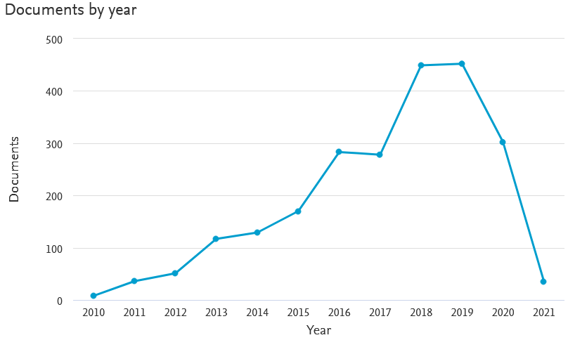

Fig.2: Published articles from 2010 to 2020

**2.1.2.2 Distribution of papers in various domains**

We have reviewed the articles identifying the use of sentiment analysis in different sectors or domains. In the Fig. 3, the contribution of various fields is recordedas percentage. It’s evident from the model that most researches are focused on computer science (47.3%),engineering(15.9%), decision science(6.9%), and social science (5.3%), business management (2.1%).

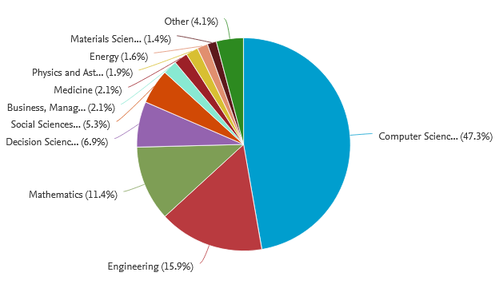

Fig. 3: Number of published articles in a different domain (2010–2020)

**2.1.2.3 Distribution of articles by authors’ contribution**

The participation of every author, scholar, and researcher with minimum contribution of 3 publications in this domain has been considered. He, y.(2015) has aced the list with the most number of publications. Following him, Kumar a.(2018) from India, Wang y.(2018), Ahmad s. are ranked top in the list.

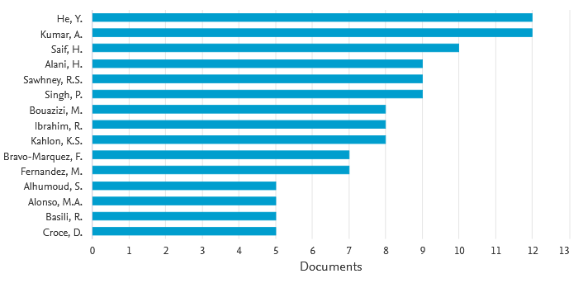

Fig. 4: Number of published articles published by different authors

**2.1.2.4 Distribution of articles by different institutes**

Contributions of different institutes have also been investigated particularly in this domain. Fig. 5 is evidently showing the results. The contribution of Vellore Institute of Technology (India) has topped the list with 28 articles. Delhi Technology University and King Saud University is almost at the same position with 25 articles. Following them the institutes, ‘Amity University Noida (23 articles)’, ‘Telkom University (20 articles)’, ‘King Abdulaziz University(18 articles)’, ‘University of Politecnica de Valencia(16 articles)’, ‘University Indonesia’ have shown considerable contribution.

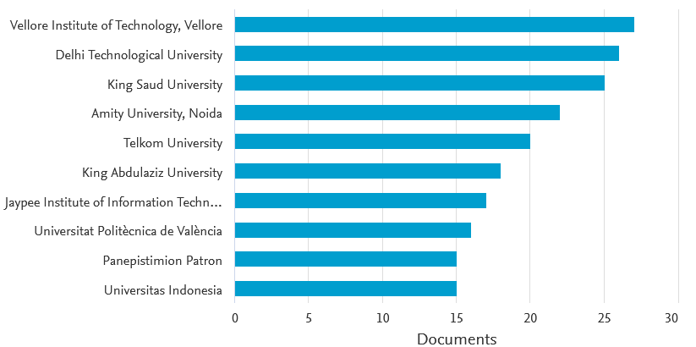

Fig. 5: Number of published articles in different institutes

**2.1.2.5 Distribution of articles by countries**

We had tried to figure out the contribution of different countries in this domain. The results are shown in Fig. 6. India has ranked first in the list with 600 publications. The United States is at 2nd position with 350 publications. Following them, United Kingdom (150), China(120), Spain (100), Indonesia (90), Italy (90) also showed participation as represented by the no of publications. Few countries, like Turkey, South Arabia, South America, displayed very less contribution over these years. Actually, the number of articles by different countries is totally different from the participation of author of the countries as the count is based on the citation given in each paper.

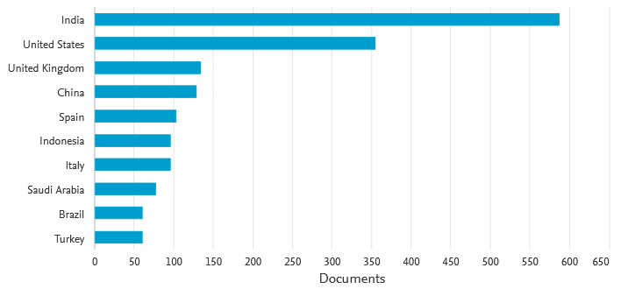

Fig. 6: Number of published articles across countries/regions

**2.1.2.6 Distribution of articles by sponsoring agencies**

Sponsoring agencies had also played a significant role over the years, 2010 to 2020. We have taken a minimum of 5 publications for investigation. The results are displayed in Fig. 7 which shows that the ‘National Natural Science Foundation’ has sponsored the largest research in the list which is 52 in numbers. It is followed by ‘National Science Foundation (49 counts), ‘National Research Foundation of Korea (24 counts), ‘European Commission’ (24 counts), ‘European Regional Development Fund’ (17 counts), ‘Ministry of Science ICT (12 counts), and ‘Japan Society for the promotion of Science (11 counts).

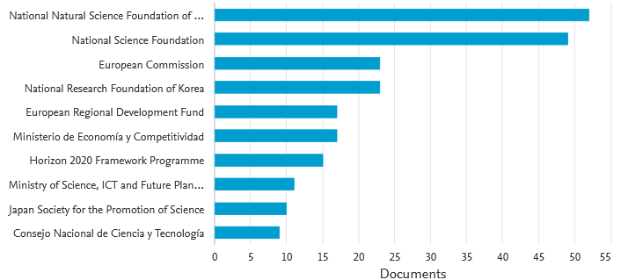

Fig. 7: Number of published articles with different sponsoring agencies

**2.1.3Scientometric analysis**

In this part, the main emphasis is on the journal sources, keywords, articles/documents, authors, and countries to determine their contribution in the domain of machine learning algorithms for sentiment analysis.

**2.1.3.1 Analysis of using journal sources**

With the help of VOSViewer, the minimum number of citations of articles is fixed at 3. 117 out of 931 journals are filtered out which met this threshold criterion. The largest connected journal has 66 journals connected to it. The result is displayed in Fig. 8. According to the picture below, it can be clearly seen that ‘Computer Science’ is the domain which has the highest contribution with maximum no of articles published. It is followed by ‘Intelligent System’, ‘ACM’, and ‘social networking’. Inter-relationships between the journals are represented by colours and the connecting lines. One article is cited in different journals. For instance, the works related to topics namely ‘Computer Science ’, ‘Intelligent system,‘ ACM’, and ‘social networking’ have been dynamically citing each other in journals. In the table below the impact of journals is shown in a quantitative (article change) way. Normalized citation is used to list the journals in the table. The topics ‘Computer Science’, ‘Artificial Intelligence advancement, and ‘Social Sciences’ topped the list.

.

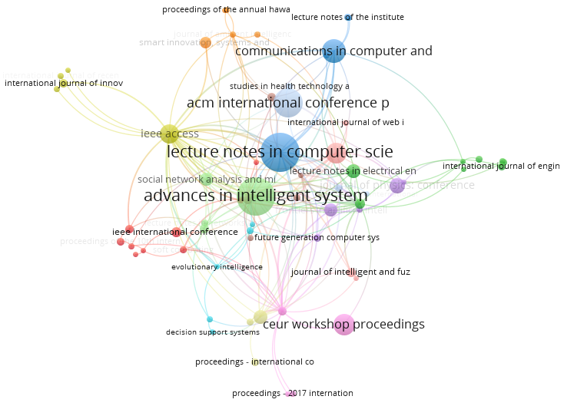

Fig. 8 Visualization of journal sources

**2.1.3.2 Analysis using authors**

With the help of VOSViewer, The minimum number of citations per article is fixed at 5 and 3

in a journal of a particular author. 277 out of 5083 journals are filtered out which met this threshold criterion. The cluster with the largest number of authors is 20 which are shown in the Fig. 9. The number of publications of each author is quantified by the circle and font size. The authors displayed in Fig. 9 are clustered into 6 groups based on their own citation networks. For example, ‘Zhang y(2018)’, ‘Wang y(2018)’, ‘yang y(2019)’, and ‘Kumar. a (2018,2017)’ appear in the same cluster as they have collaborated and worked mutually on the research. The relation among authors has been investigated with the help of connection lines and distance between them, as shown in the figure below. For example, ‘Zhang b(2016).’, ‘Youn HY.’ , and ‘Lim(2016) ’ can be found with strong linkage in this domain. The impact of authors is listed in Table 3; ‘Normalised Citation’ score is used to list the authors in Table 3. The authors ‘Maiti J.’, ‘Chen x (2015)’, and ‘Zang s (2017)’ topped the list on the basis of citation score.

‘Zang-h.’ has only 2 publications as per average normalised citation score. On the basis of average citation and total citation, Saif-h(2016)’, ‘Chae b. (2015).’, and ‘Hussain at(2018)’ are considered to have the highest contributions in this domain. The most productive authors are ‘Sawhneyr.s’, ‘Singh p(2016)’, ‘Kahlonk.s.’ and ‘Ibrahim r(2016)’ based on the no of publications in the research.

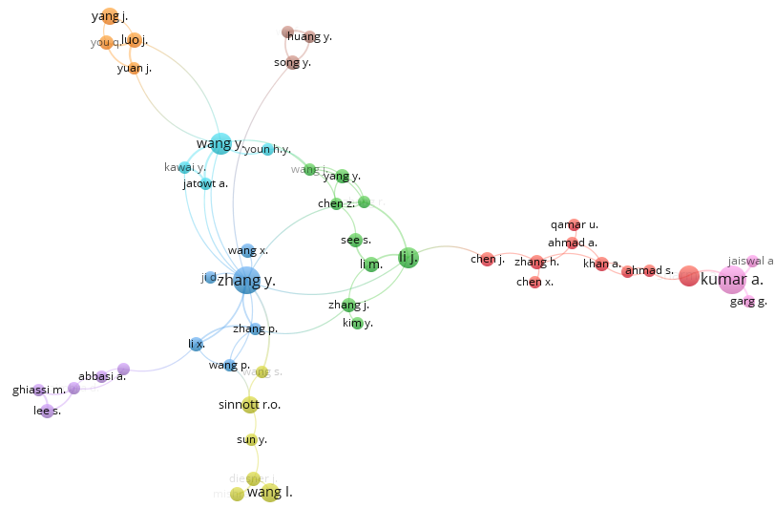

Fig. 9. Visualization of authors

Table 3. A summary exploring the impacts of authors

|  |  |  |  |
| --- | --- | --- | --- |
| **Author** | **Documents** | **citations** | **Total link strength** |
| Singh p. | 12 | 49 | 20 |
| Sawhneyr.s. | 9 | 49 | 20 |
| kahlonk.s. | 8 | 44 | 19 |
| Zhang y. | 15 | 353 | 15 |
| Ibrahim r. | 8 | 55 | 14 |
| Selamat a. | 7 | 51 | 14 |
| Zainuddin n. | 7 | 51 | 14 |

**2.1.3.3 Analysis using authors’ keywords**

Keywords indicate the prime context of any study and related research themes in a particular domain. The strength of relationship amongst the keywords is denoted by their co-occurrences.

Primarily, the common keywords are removed which include ‘sentiment analysis, ‘text mining’, ‘social media’ and so on. Then, using VOSViewer with fractional counting by setting the min no of occurrences of a keyword is 5, as a result of which 762 keywords are selected out of 7703.

The keywords, including ‘sentiment analyses, ‘social networking (online)’, ‘data mining’,

‘Twitter’ and ‘social media’ have been used more frequently in this domain and 11 clusters are formed using these keywords. Inter-relationship of keywords present in the same cluster is stronger. Inter-relatedness among keywords is represented by distance and connection line. For example, SVM and machine learning are often used for detecting sentiments. The number of keywords in a particular article is denoted by font size. The most used keywords in recent studies include ‘social networking, ‘ML, ‘supervised learning, ‘text mining’. In Table 4 the keywords are written in accordance with their ‘average normalized citation’. The keywords ‘text mining’, ‘big data, ‘multilayer neural network, ‘forecasting, are at the top of the list according to the average normalized citation score. In recent years ‘text mining’, ‘support vector machine’, ‘decision tree ', ‘random forest’, and ‘classification’ are gaining more importance as shown in Table 4.

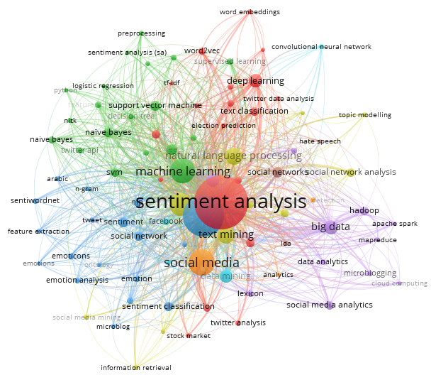

Fig. 10. Visualization of Author Keywords

Table 4. Quantitative summary of the influence of keywords

|  |  |  |
| --- | --- | --- |
| **Keyword** | **Occurrences** | **total link strength** |
| Social networking (online) | 1896 | 18421 |
| Sentiment analysis | 1907 | 18159 |
| Data mining | 1050 | 10877 |
| Twitter | 759 | 7377 |
| Social media | 545 | 5163 |
| Learning systems | 398 | 4972 |
| Classification (of information) | 367 | 4460 |

**2.1.3.4 Analysis of using articles**

Articles or documents are used for Scientometric analysis; we fixed the min number of citations at 5 by using fractional counting methods. The result of which 852 documents are selected out of 2000 which meet the about the condition. Only 588 documents out of 852 documents have a strongly connected network which is shown in Fig. 11. In Table 5, articles are listed on the basis of citation score for high to low. On the basis of normalized citation most influential articles shown in the table. Only the top few articles with respective normalized citation are shown in table from the 588 articles. For example, the study of saif h. (2016) focused on the contextual semantics for sentiment analysis of Twitter, JianQiang z. (2017) used a big database for analysis, he w. (2015) used social media analytic framework. From these articles, it is clear that application of machine learning in discovering sentiment on social media platformis gaining more attention among scholars.

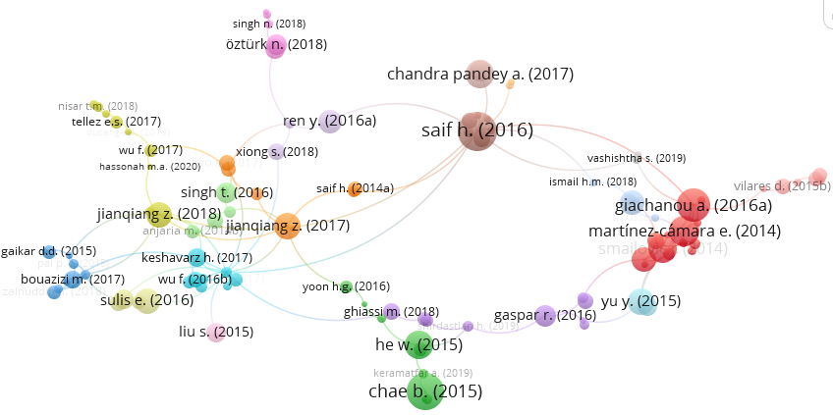Fig. 11. Visualization of Documents

Table 5. A summary showing the articles with higher citations

|  |  |  |
| --- | --- | --- |
| **Document** | **Citations** | **Links** |
| Saif h. (2016) | 212 | 21 |
| Kumar a. (2020) | 18 | 15 |
| Jianqiang z. (2018) | 92 | 14 |
| Giachanou a. (2016a) | 151 | 10 |
| Yu y. (2015) | 98 | 9 |
| Jianqiang z. (2017) | 96 | 9 |
| Rill s. (2014) | 83 | 8 |

**2.1.3.5 Analysis of using countries**

With the help of VOSViewer, the maximum number of authors/documents is 25, the minimum no of documents/ country is 5 and the minimum no of citation of a country is zero. Using these criteria 54 countries are selected out of 95, which form a large set of connected countries contributing to research. Same arerepresented in the figure below. The number of publications in a particular domain for each country is represented by circle size and the font used. In Fig. 11 the countries are grouped into 5 on the basic of a citation network. For example, ‘India’, ‘China’, ‘Japan’, and ‘United Kingdom’ are grouped in the same cluster which shows the mutual weight age by giving citations to each study. The connection lines along with the distance between nodes are used to study the impact of countries on each other as shown in the figure below. ‘India’, ‘China’, ‘US, and ‘UK’ are found to have a strong linkage in this domain. Normalized citation score is used to categories these countries in the list. Countries like ‘US, ‘China’, ‘Italy’, ‘Spain’, and ‘Australia’ top the table based on the normalized score. The highest contribution in the academic literature of this domain is by countries like ‘US, ‘China’, ‘Italy’, ‘Spain’, based on no of citations they top the list. According to the average citation score, the top 5 countries in the list are ‘Australia’, ‘Canada’, ‘China’, and ‘Germany’. On basis of average publication per year many countries are contributing except ‘US, ‘India’, ‘UK, ‘China’, and ‘Spain’.

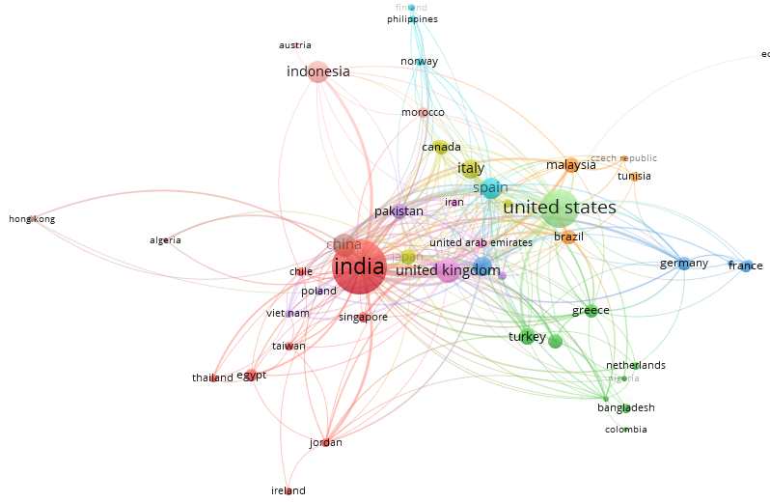

Fig 12. Visualization of countries

**Section 2.2: Reviews on literature**

Sentiment analysis has become very common in recent years amongst various authors and researchers, who have used this in a various domains to have superior understanding of the emotions of people regarding particular events, sectors or domains. Let us go through the works of some researchers in this domain.

* In Hospitality Sector, there is increase in customer requirements regarding improved quality, better services, competitive pricing and satisfactory experience and this can be easily achieved by understanding the emotions of customers using machine learning techniques [Sanchez-Franco, Manuel J.; Cepeda-Carrion, Gabriel; Roldan, Jose L.] 2019 tried to find out the quality of the relationship among hotel co-workers. [Srivastava, Saurabh Kumar; Singh, Sandeep Kumar; Suri, Jasjit S.] 2019 utilised medical data to analyse predictability. [Sadilek, A; Kautz, H; DiPrete, L; Labus, B; Portman, E; Teitel, J; Silenzio, V ] 2017 tried machine learning algorithms to reduce the chances of death by food prone diseases.
* Stock Market is a place of sentiments where results mostly depend on the sentiments of the public and the market reacts accordingly. Researchers have used various ways to predict the results of the stock market by ML algorithms and predictive analysis. [Picasso, Andrea; Merello, Simone; Ma, Yukun; Oneto, Luca; Cambria, Erik] 2019 tried to predict stock prices of companies listed in NASDAQ100 index using time-series data. [Ren, Rui; Wu, Desheng Dash; Liu, Tianxiang] 2019 used a support vector machine (SVM) to predict the direction of a moment in SSE 50index. Some stocks give abnormal returns annually for that [Hajek, Petr] 2018 use combinations of algorithms i.e (SVM, C4.5 decision tree, and KNN) for US firms annual report. Volatility is a major factor in the stock market [Oliveira, Nuno; Cortez, Paulo; Areal, Nelson] 2017 tries to find the impact of social media on volatility in the S&P 500 Index.
* In Technology sector, after advancement cyberbullying and bots on social media sites are impacting the results very much [Zhao, Rui; Mao, Kezhi ]2017, [Al-garadr, Mohammed Ali; Varathan, KasturiDewi; Ravana, Sri Devi]2016, [Zheng, Xianghan; Zeng, Zhipeng; Chen, Zheyi; Yu, Yuanlong; Rong, Chunming]2015, [Rong, Wenge; Nie, Yifan; Ouyang, Yuanxin; Peng, Baolin; Xiong, Zhang]2014 uses social media data to detect spamming. [Alvaro, Nestor; Conway, Mike; Doan, Son; Lofi, Christoph; Overington, John; Collier, Nigel] 2019 use various drugs name on Twitter to filter self-reported cases of drug abuse.
* In various social events like US elections, movie reviews,drug abuse, domestic violence and cyberbullying can also be controlled by these predictive models. [Guess, A; Munger, K; Nagler, J; Tucker, J] 2019 tried to predict US election results, [Rui, Huaxia; Liu, Yizao; Whinston, Andrew] 2013 and [Parlar, Tuba; Ozel, Selma Ayse; Song, Fei] 2018 tried to predict sales of movies. [Barker, J. L. P.; Macleod, C. J. A.] 2019 Tries to track emotionof people on flood warning. Domestic Violence impact human mental health a lot so[Subramani, Sudha; Wang, Hua; Vu, HuyQuan; Li, Gang] 2018 uses social media datato support victims. [Vioules, M. Johnson; Moulahi, B.; Aze, J.; Bringay, S.] 2018 uses socialmedia for change in user’s online behaviour to detect signs of suicidal indication and tries topropose a model which can predict these signs so that we can handle such emergency.

Classification of messages which are circulated on social media platforms into positive, negative or neutral is polarity detection. [Ortigosa, Alvaro; Martin, Jose M.; Carro, Rosa M.]2014 used combinations of various ML techniques to analyse how beneficial are the expressed emotions of students on Facebook for the e-learning courses; the accuracy they achieved is 82.27%. [Al-Smadi, Mohammad; Al-Ayyoub, Mahmoud; Jararweh, Yaser; Qawasmeh, Omar] 2019 with help of Naive Bayes, Bayes Networks, Decision Tree, KNN, SVM analysed Arabic Hotel reviews for polarity amongst employees and SVM are best performing classifier. NLP (Natural Language Processing) is one of the most common techniques used for sentiment analysis because many times people use abbreviations or miss-spelling of certain words which make it a tough task to extract sentiments from that message for simple ML algorithms. [Rehman, Anwar Ur; Malik, Ahmad Kamran; Raza, Basit; Ali, Waqar] 2019 use NLP and CNN to understand sentiments of movie reviews. Use of Satires may change the whole meaning of a sentence if not handled carefully [del Pilar Salas-Zarate, Maria; Andres Paredes-Valverde, Mario; Rodriguez-Garcia, Miguel Angel; Valencia-Garcia, Rafael; Alor-Hernandez, Giner] 2017 uses Twitter data for differentiating satirical and non-satirical news using NLP as it works best these data and achieved 85% accuracy.

Whenever we buy products online then most of the times reviews of recent buyers plays a major is the decision-making process and for understanding the same [Kim, Yoosin; Dwivedi, Rahul; Zhang, Jie; Jeong, SeungRyul] 2015 tried to compare sentiments of people for Iphone6 and GalaxyS5 using social media opinion.

Apart from text messages, facial expressions is also a method to express emotions and Instagram is one of such social media platforms which promotes images, gif and videos rather than text. In 2019 [Sajjad, Muhammad; Nasir, Mansoor; Ullah, Fath U. Min; Muhammad, Khan; Sangaiah, Arun Kumar; Baik, Sung Wook] tried various data sets to predict emotions behind the scene by SVM and proposed a method which can be the used of security purpose also. [Choudhury, Prithwiraj; Wang, Dan; Carlson, Natalie A.; Khanna, Tarun] 2019 used video of CEOs of various companies to predict the decision they will take by monitoring both verbal and non-verbal communication.

Supervised ML are the most common techniques being used for detecting sentiments and along with it Deep learning, Neural network, NLP, n-gram, CNN, Random forest are also gaining popularity.

**3. Case Study of Covid-19 sentiment analysis on Twitter using Cognitive Services**

Twitter is a micro blogging site on which people express their views and emotions in short messages of 240 words called tweets which also allows posting photos and videos as well. However in this paper, we are only focused towards text messages by real time active users on this platform regarding Covid-19. Cognitive services is a combination of various machine learning algorithms combined by Microsoft to find solutions in various domains. Basically, it deals in 4 major categories - (i) Vision: where pictures and visuals are analysed, (ii) speech: where identification of a person is done through speech pattern, (iii) Language: which is used to analyse the sense of a full sentence rather than focusing on specific words, (iv) Search: use ML algorithms to search relevant results on the internet. 13825 articles were found according to the Scopus database in 10 years when searched for “twitter” keyword which is shown in Fig 13. It signifies the use of information on Twitter is utilised effectively for research purposes. When searched for “cognitive services” keyword,Fig 14 is showing that very few researchers use cognitive services as a tool for sentiment analysis.

Let’s try to find out literature regarding use of twitter as base social media platform for collection of data to understand the emotions of people under certain condition, event and product experience. In 2015 (Alvaro, Nestor; Conway, Mike; Doan, Son; Lofi, Christoph; Overington, John; Collier, Nigel)used information’s form twitter to gather firsthand experience of drug useby NLP technique as many of the tweets are in different language and sometime acronyms are used to convey messages. SVM is used **by** (Zheng, Xianghan; Zeng, Zhipeng; Chen, Zheyi; Yu, Yuanlong; Rong, Chunming) in 2015 for detecting spam accounts on three different social media platforms – Facebook, My Space, Twitter specifically how these accounts honey trap the users. Online shopping is very popular now a days and the users use social media to know more about the product of their choice as lot of people are giving reviews after getting the products that actually helps a new consumer to a primary idea about the product (Kim, Yoosin; Dwivedi, Rahul Zhang, Jie; Jeong, SeungRyul) used NLP and sentiment analysis to compare Iphone 6 and Galaxy S5 with help of twitter information. In 2020 (Binti Hamzah F.A., Lau C., Nazri H., Ligot D.V., Lee G., Tan C.L., et al.) proposed a Coronatracker by using SIER model and done sentiment analysis worldwide to track recent cases of covid.(Samuel J., Ali G.G.M.N., Rahman M.M., Esawi E., Samuel Y.) to understand the sentiments of people regarding Covid-19 used machine learning algorithms (Linear regression, Logistic regression, Naïve Bayes classifier, K-Nearest Neighbour) on tweets, short tweets are producing 91% accuracy.

**3.1 Research Gap / Motivation**

Twitter is one of the most popular social networking sites now, which can be used as a database of studying sentiment analysis. This study is conducted into two parts (i) tweets on Covid-19 situation and (ii) retweets regarding Covid-19. For the collection of tweets, we have use Microsoft flow and CDS(common depository services) has been used to store it. The dataset is extracted by using keywords: ‘covid’, ‘covid19’, ‘covid vaccine’,‘#covid’, ‘covid pandemic’. When retweets are considered many users also link Donald Trump and WHO with covid-19 information. The pattern of tweets and retweets shows that people are behaving in a very random manner as they don’t have access to proper information so a lot of misleading information is being circulated. This actually makes it difficult for a covid-19victim to collect relevant information on what to do when symptoms of this infection are detected. We have tried to create a run time model with help of Microsoft flow, power automate and cognitive services to act as a filter for proper information. The tweets are categorised into three categories- positive, negative and neutral.

**3.2 Research Objective**

This study's primary objective is to find out a suitable algorithm apt for sentiment analysis that can handle run-time data and produce an accurate result as social networking sites allows multiple languages for expressing the views along with various symbols like emoji, which creates confusion for a machine learning model to interpret and analyse it.

**3.3 Research methodology**

**3.3.1 Data Collection**

We are analysing on run time data which is why we are using Microsoft Flow and power app for collecting messages (tweets) from Twitter and storing it into CDS (common database). Both the training data set and test data set are picked from Twitter. We have used tweets having keywords (‘covid’, ‘covid19’, ‘covidvaccine’, ‘#covid’) as a training dataset named as D1, and when these tweets are retweeted we capture these on the basis of tweet id and consider it as a test data set named as D2.

Fig. 15 shows the use of Microsoft flow for the collection of tweets when any tweet is posted with mentioned keywords such that it gets stored in CDS and generates a database of our study. Various other information is also stored such as tweet location, tweet id, profile picture, language. Tweet id plays a major role while collecting and sorting data into D1 or D2 as retweets are identified on the basis of this unique tweet id. The step wise detailed process of data collection and sorting is discussed below.

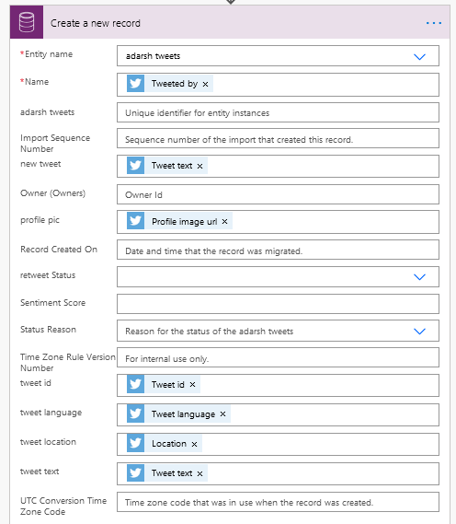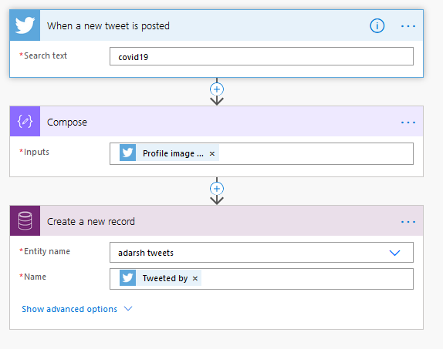

Fig. 13 Showing Microsoft flow used for searching tweets and storing information

Fig. 14 Showing various details or tweets are considered

The process we used for this case study is as follows: (i) firstly we collected tweets by using Microsoft flow and stored it for making a database for analysis where tweets were selected by the keywords used in them; (ii) tweets were filtered on the basis of the language of tweets (we only selected tweets in the English language as it is the most common language all over the world) and considered text no pictures and videos are usedin this study; (iii) filtered tweets are used in Microsoft cognitive services and scored accordingly into neutral, positive and negative; (iv) Storing these scores along with tweet id in .csv format in Google drive for cross referencewith future data using same keywords by Microsoft flow on retweets and fresh tweets which werethen filtered on the basis tweet id; (v) Filtered tweets are sent to cognitive services categorising them into neutral, positive or negative and storing scores in google sheet along with spreadsheet as shown in figure.17 ; (vi) The classified dataset D1 and D2 are used in the same way to store more tweets and compare with help of machine learning algorithms that how many times these were retweets.

The whole sentiment of a tweets is judged on the basis of combinations of words used and as shown in Fig. 17, tweets having score 0.5 are considered as neutral whereasthe ones having score below 0.5 are considered negative and tweets having score tweets above 0.5 are considered to be positive. Here we have considered the score scale from 0 to 1 as prescribed by Microsoft cognitive services which may be altered to some other scale as required by end user.

If required a user may refer to below link for detailed study of how to use or modify parameters of cognitive services as per ones requirement. (<https://docs.microsoft.com/en-us/azure/cognitive-services/text-analytics/how-tos/text-analytics-how-to-sentiment-analysis?tabs=version-3-1>)

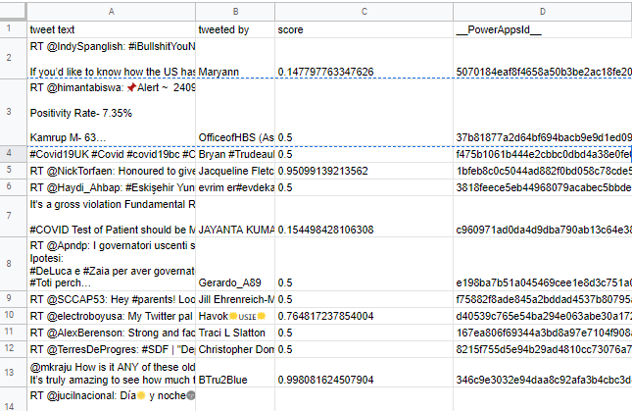

Fig. 15: Tweets are displayed along with score- Negative, positive and neutral.

This fig shows that people are confused and mixed type of responses are there since they are not aware regarding preventive measures of Covid-19.

**3.3.2 Data Pre-processing**

We have basically used two classification machine learning algorithms for comparing the number of tweets which are retweeted on the basis of tweet id. Random forest and SVM(Support vector machine) are used for the classification of tweets into two classes. First-class tweets are totally new and second class tweets are retweeted.

As we used D1 for the training of these algorithms so it easily detects the tweets which are retweeted, classify and place the fresh tweets in one class and retweets in other class. When we use D2 then our trained classifier will separate tweets into two classes one containing fresh tweets and other with tweets recirculated on Twitter. Then will compare the scores of tweets which are retweeted as people when retweeting any tweets they also link other similar tweets into it or mention more related emotions on that topic.

**3.3.3 Data Classification**

There are multiple techniques which may be employed for classification of gathered data. We have utilised two amongst the available techniques, which have been elaborated as under.

**3.3.3.1 Support Vector Machine (SVM)**

(Pang and Lee 2002) used SVM for classifying tweets and depicted it as very useful forcategorising into negative or positive. We used the default setting for the SVM algorithm in Sklearn Library (<https://scikit-learn.org/stable/modules/svm.html>).

We will try to alter the parameters and kernels in future studies of improving accuracy, with default setting we attained 78% accuracy

-----------------------------------------------CODE---------------------------------------------------------

fromsklearn.model_selectionimporttrain_test_split

X_D1train, X_D2test, y_D1train, y_D2test = train_test_split(X, y, test_size=0.2, random_state=0)

fromsklearnimportsvm

model = svm.SVC(kernel='linear')

model.fit(X_D1train, X_D2train)

pred = clf.predict(y_D2test)

fromsklearnimport metrics

print("Accuracy:",metrics.accuracy_score(y_D2test, pred))

print("Precision:",metrics.precision_score(y_D2test, pred))

print("Recall:",metrics.recall_score(y_D2test, pred))

----------------------------------------------------------------------------------------------------------------

**3.3.3.2 Random Forest**

Random forest is one of the most used ensembler( Breiman, 1996, Dietterich 2000) that shows it is more effective in case of noisy data sets. We used the default setting for the SVM algorithm in the Sklearn library.

(<https://scikit-learn.org/stable/modules/generated/sklearn.ensemble.RandomForestClassifier.html>)

-----------------------------------------------CODE---------------------------------------------------------

fromsklearn.model_selectionimporttrain_test_split

X_D1train, X_D2test, y_D1train, y_D2test = train_test_split(X, y, test_size=0.2, random_state=0)

fromsklearn.preprocessingimportStandardScaler

sc = StandardScaler()

X_D1train = sc.fit_transform(X_D1train)

X_D2test = sc.transform(X_D2test)

fromsklearn.ensembleimportRandomForestRegressor

regressor = RandomForestRegressor(n_estimators=20, random_state=0)

regressor.fit(X_D1train, y_D1train)

pred = regressor.predict(X_D2test)

fromsklearnimport metrics

print('Mean Squared Error:', metrics.mean_squared_error(y_D2test, pred))

fromsklearn.metricsimportclassification_report, confusion_matrix, accuracy_score

print(confusion_matrix(y_D2test, pred))

----------------------------------------------------------------------------------------------------------------

**3.3.4 Data Analysis**

After the data gathering process is complete and scoring of sentiments is done, there are multiple methods available for testing the accuracy of a machine learning algorithms. We have tested our model using four methods which have been discussed below.

**3.3.4.1 Precision**

According to Wikipedia (https://en.wikipedia.org/wiki/Precision_and_recall): precision is the fraction of retrieved documents that are relevant to the query:

Precision is defined as the ratio between true positive and the sum of true positive with false positive, it means the ratio between actual data point versus all the data points whether it is correctly classified or not. Davis, J., &Goadrich, M. (2006) very well describes precision and recall,

The precision of SVM is better than Random forest-based on data set. 0.832 is for SVM, we consider it to multiply by 100 for percentage.

Precision = precision = | { relevant documents } ∩ { retrieved documents } | | { retrieved documents } | {\displaystyle {\text{precision}}={\frac {|\{{\text{relevant documents}}\}\cap \{{\text{retrieved documents}}\}|}{|\{{\text{retrieved documents}}\}|}}}

Precision = precision = | { relevant documents } ∩ { retrieved documents } | | { retrieved documents } | {\displaystyle {\text{precision}}={\frac {|\{{\text{relevant documents}}\}\cap \{{\text{retrieved documents}}\}|}{|\{{\text{retrieved documents}}\}|}}}.

**3.3.4.2 Recall**

According to Wikipedia (https://en.wikipedia.org/wiki/Precision_and_recall) In information retrieval, recall is the fraction of the relevant documents that are successfully retrieved.

Recall is the ratio between true positive and sum of true positive with a false negative. It means the ration of correctly classified data point versus the sum of correctly classified data points and wrongly classified data points

Recall =

Recall = precision = | { relevant documents } ∩ { retrieved documents } | | { retrieved documents } | {\displaystyle {\text{precision}}={\frac {|\{{\text{relevant documents}}\}\cap \{{\text{retrieved documents}}\}|}{|\{{\text{retrieved documents}}\}|}}}

Recall value actually shows how accurately our algorithm classified the data, in other words also seen as the sensitivity of model proposed

**3.3.4.3 F1- Score**

When we are not very sure from the precision or recall values then we often use F1 score for checking how well our algorithm performs. According to Wikipedia (<https://en.wikipedia.org/wiki/F-score> )

F1 =

**3.3.4.4 MSE (Mean Square Error)**

It actually shows the incompetence of the model, where the model fails to predict accurately. The purpose of using means of square error is to magnify the error by squaring it so that we can easily find it.

MSE =

**4. Results and Discussions**

The above case study yielded results as per table 6.

Table 6: Comparison of two machine algorithms used for comparing D1 and D2

|  |  |  |  |  |
| --- | --- | --- | --- | --- |
| **Algorithm used** | **F1-score** | **Precision** | **Recall** | **MSE** |
| **Random forest** | 75% | 80.12% | 81.47% | 0.18 |
| **SVM** | 78% | 83.2% | 84.56% | 0.15 |

The results in table 7 clearly indicates that SVM is working little better than random forest for classifying the data points (tweets) into two classes and produces comparably less error and accuracy which is imminent as per F1-score, precision, recall and MSE comparative analysis.

Now will again use cognitive services for analysing the emotions of people on the basis of score of re-tweets.

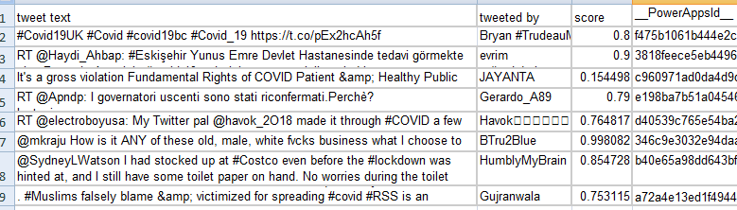

Fig. 16: Showing retweets and score

**4.1 Research issues**

While reviewing the researches by the bibliometric analysis several issues are encountered like very few authors have taken real-time data into consideration which utilising the machine learning models efficiency in detection of sentiments. Data sources used are also not that much effective as they are now on varioussocial media platforms available to express the views and opinion.

The text of the messages on social media is generally in different languages so there is no proper system available to filter these variations. The NLP developed in cognitive services offers facility to convert text from other languages to English however, it creates a gap where the emotions are changed than the original expression of user. So, as of now we have filtered out the data from languages other than English to avoid deviation from original major public opinion.

**5. Conclusion**

In this article, we tried to present a survey which includes all pre-existing techniques of machine learning used for detecting sentiments. In today’s time, social media is one of the most common ways all over the world for sharing the sentiments, various posts are shared on daily basis this data can be very useful for predicting the output of any event.All techniques suggested from 2010-2020 are sufficient for such a large amount of data and then filtering it for accurate results is a big challenge. In future studies, one can try to propose algorithms which can handle a big chunk of data irrespective of languages used in the text.

We had earlier proposed three research questions for which will now look into our findings.

R1: To understand the existing research work on sentiment analysis about Covid-19.

Since, no proper information was available to mass public from primary authorities who themselves were not completely familiar with Covid-19 so people use secondary sources such as media channels and social media platforms to learn more regarding Covid-19 particularly for the safety of their loved ones. This information may not be completely true and sometimes even altered through the way of its presentation and choice of phrases which are the tools of critics.

R2: To propose a logical method and its application to understand the humans thoughts about Covid-19 though tweets on Twitter

People either extrovert or introvert are still social beings they have a network of people whom they trust, these people in continuation have their trusted sources / networks so if any fact which may be true or biased is circulated will eventually reach the general public through one way of the other which empowers the receiver that it is true. Also, while propagation of information is maybe slightly modified intentionally or unintentionally leading to critical situations of fear and chaos which was in the case of Covid-19.

When D2 is analysed people are mostly sending negative tweets and misleading information. Because no proper information or guidelines are there, so they are a puzzle. One more reason is that there so much negative tweets and it is human nature when a person sees information then he will add more similar information or similar negative #hastags or keywords the retweet that message so score are mostly on negative side. Due to lack of awareness in people regarding covid-19 people unwillingly spreading wring information more no of re-tweets shows this clearly. This pandemic created a chaos people as this one of its kind situation even WHO is also unaware about the proper procedure. All concerned authorities should use these models to stop the spread of wrong information. Machine learning or emotional intelligence can be used to filter positive tweets and resending it can help people to create a positive environment. This step is not a solution but can benefit to control the situation.

**6. References**

Al-garadi, M. A., Varathan, K. D., &Ravana, S. D. (2016). Cybercrime detection in online communications: The experimental case of cyberbullying detection in the Twitter network. *Computers in Human Behavior*, *63*, 433-443.

Al-Smadi, M., Al-Ayyoub, M., Jararweh, Y., &Qawasmeh, O. (2019). Enhancing aspect-based sentiment analysis of Arabic hotels’ reviews using morphological, syntactic and semantic features. *Information Processing & Management*, *56*(2), 308-319

Alvaro, N., Conway, M., Doan, S., Lofi, C., Overington, J., & Collier, N. (2015). Crowdsourcing Twitter annotations to identify first-hand experiences of prescription drug use. *Journal of biomedical informatics*, *58*, 280-287.

Alvaro, N., Conway, M., Doan, S., Lofi, C., Overington, J., & Collier, N. (2015). Crowdsourcing Twitter annotations to identify first-hand experiences of prescription drug use. *Journal of biomedical informatics*, *58*, 280-287.

Barker, J. L. P., & Macleod, C. J. (2019). Development of a national-scale real-time Twitter data mining pipeline for social geodata on the potential impacts of flooding on communities. *Environmental modelling & software*, *115*, 213-227.

Barkur, G., &Vibha, G. B. K. (2020). Sentiment analysis of nationwide lockdown due to COVID 19 outbreak: Evidence from India. *Asian journal of psychiatry*.

Bollen, J., Mao, H., & Zeng, X. (2011). Twitter mood predicts the stock market. *Journal of computational science*, *2*(1), 1-8.

Choudhury, P., Wang, D., Carlson, N. A., & Khanna, T. (2019). Machine learning approaches to facial and text analysis: Discovering CEO oral communication styles. *Strategic Management Journal*, *40*(11), 1705-1732.

CoronaTracker: worldwide COVID-19 outbreak data analysis and prediction. *Bull World Health Organ*, *1*(32).

Davis, J., &Goadrich, M. (2006, June). The relationship between Precision-Recall and ROC curves. In *Proceedings of the 23rd international conference on Machine learning* (pp. 233-240).

delPilar Salas-Zárate, M., Paredes-Valverde, M. A., Rodriguez-García, M. Á., Valencia-García, R., &Alor-Hernández, G. (2017). Automatic detection of satire in Twitter: A psycholinguistic-based approach. *Knowledge-Based Systems*, *128*, 20-33.

Dietterich, T. G. (2000, June). Ensemble methods in machine learning. In *International workshop on multiple classifier systems* (pp. 1-15). Springer, Berlin, Heidelberg.

Guess, A., Munger, K., Nagler, J., & Tucker, J. (2019). How accurate are survey responses on social media and politics?.*Political Communication*, *36*(2), 241-258.

Hájek, P. (2018). Combining bag-of-words and sentiment features of annual reports to predict abnormal stock returns. *Neural Computing and Applications*, *29*(7), 343-358.

Hamzah, F. B., Lau, C., Nazri, H., Ligot, D. V., Lee, G., & Tan, C. L. (2020).

He, W., Xu, G., Kim, Y., Dwivedi, R., Zhang, J., &Jeong, S. R. (2016). Competitive intelligence in social media Twitter: iPhone 6 vs. Galaxy S5. *Online Information Review*.

Medhat, W., Hassan, A., &Korashy, H. (2014). Sentiment analysis algorithms and applications: A survey. *Ain Shams engineering journal*, *5*(4), 1093-1113.

Oliveira, N., Cortez, P., & Areal, N. (2017). The impact of microblogging data for stock market prediction: Using Twitter to predict returns, volatility, trading volume and survey sentiment indices. *Expert Systems with Applications*, *73*, 125-144.

Ortigosa, A., Martín, J. M., &Carro, R. M. (2014). Sentiment analysis in Facebook and its application to e-learning. *Computers in human behavior*, *31*, 527-541.

Parlar, T., Özel, S. A., & Song, F. (2018). QER: a new feature selection method for sentiment analysis. *Human-centric Computing and Information Sciences*, *8*(1), 10.

Picasso, A., Merello, S., Ma, Y., Oneto, L., & Cambria, E. (2019). Technical analysis and sentiment embeddings for market trend prediction. *Expert Systems with Applications*, *135*, 60-70.

Rehman, A. U., Malik, A. K., Raza, B., & Ali, W. (2019). A hybrid CNN-LSTM model for improving accuracy of movie reviews sentiment analysis. *Multimedia Tools and Applications*, *78*(18), 26597-26613.

Ren, R., Wu, D. D., & Liu, T. (2018). Forecasting stock market movement direction using sentiment analysis and support vector machine. *IEEE Systems Journal*, *13*(1), 760-770.

Rong, W., Nie, Y., Ouyang, Y., Peng, B., &Xiong, Z. (2014). Auto-encoder based bagging architecture for sentiment analysis. *Journal of Visual Languages & Computing*, *25*(6), 840-849.

Rui, H., Liu, Y., &Whinston, A. (2013). Whose and what chatter matters? The effect of tweets on movie sales. *Decision support systems*, *55*(4), 863-870.

Sadilek, A., Kautz, H., DiPrete, L., Labus, B., Portman, E., Teitel, J., &Silenzio, V. (2017). Deploying nEmesis: Preventing foodborne illness by data mining social media. *AI magazine*, *38*(1), 37-48

Sajjad, M., Nasir, M., Ullah, F. U. M., Muhammad, K., Sangaiah, A. K., &Baik, S. W. (2019). Raspberry Pi assisted facial expression recognition framework for smart security in law-enforcement services. *Information Sciences*, *479*, 416-431.

Samuel, J., Ali, G. G., Rahman, M., Esawi, E., & Samuel, Y. (2020). Covid-19 public sentiment insights and machine learning for tweets classification. *Information*, *11*(6), 314.

Sanchez-Franco, M. J., Cepeda-Carrion, G., &Roldán, J. L. (2019). Understanding relationship quality in hospitality services. *Internet Research*.

Srivastava, S. K., Singh, S. K., &Suri, J. S. (2019). Effect of incremental feature enrichment on healthcare text classification system: A machine learning paradigm. *Computer methods and programs in biomedicine*, *172*, 35-51.

Stringhini, G., Kruegel, C., &Vigna, G. (2010, December). Detecting spammers on social networks. In *Proceedings of the 26th annual computer security applications conference* (pp. 1-9).

Subramani, S., Wang, H., Vu, H. Q., & Li, G. (2018). Domestic violence crisis identification from facebook posts based on deep learning. *IEEE access*, *6*, 54075-54085.

Tumasjan, A., Sprenger, T. O., Sandner, P. G., &Welpe, I. M. (2011). Election forecasts with Twitter: How 140 characters reflect the political landscape. *Social science computer review*, *29*(4), 402-418.

Vioules, M. J., Moulahi, B., Azé, J., &Bringay, S. (2018). Detection of suicide-related posts in Twitter data streams. *IBM Journal of Research and Development*, *62*(1), 7-1.

Zhao, R., & Mao, K. (2016). Cyberbullying detection based on semantic-enhanced marginalized denoising auto-encoder. *IEEE Transactions on Affective Computing*, *8*(3), 328-339.

Zheng, X., Zeng, Z., Chen, Z., Yu, Y., &Rong, C. (2015). Detecting spammers on social networks. *Neurocomputing*, *159*, 27-34.

Singh, M., Jakhar, A. K., & Pandey, S. (2021). Sentiment analysis on the impact of coronavirus in social life using the BERT model. *Social Network Analysis and Mining*, *11*(1), 1-11.

Piccinelli, S., Moro, S., & Rita, P. (2021). Air-travelers' concerns emerging from online comments during the COVID-19 outbreak. *Tourism Management*, *85*, 104313.

Praveen, S. V., Ittamalla, R., & Deepak, G. (2021). Analyzing Indian general public's perspective on anxiety, stress and trauma during Covid-19-A machine learning study of 840,000 tweets. *Diabetes & Metabolic Syndrome: Clinical Research & Reviews*.

Saxena, A., Kushik, N., Chaurasia, A., & Kaushik, N. (2020). Predicting the outcome of an election results using sentiment analysis of machine learning. In *International Conference on Innovative Computing and Communications* (pp. 503-516). Springer, Singapore.

Yi, S., & Liu, X. (2020). Machine learning based customer sentiment analysis for recommending shoppers, shops based on customers’ review. *Complex & Intelligent Systems*, *6*(3), 621-634.

Awajan, I., Mohamad, M., & Al-Quran, A. (2021). Sentiment Analysis Technique and Neutrosophic Set Theory for Mining and Ranking Big Data From Online Reviews. *IEEE Access*, *9*, 47338-47353.

Basiri, M. E., Kabiri, A., Abdar, M., Mashwani, W. K., Yen, N. Y., & Hung, J. C. (2020). The effect of aggregation methods on sentiment classification in Persian reviews. *Enterprise Information Systems*, *14*(9-10), 1394-1421.